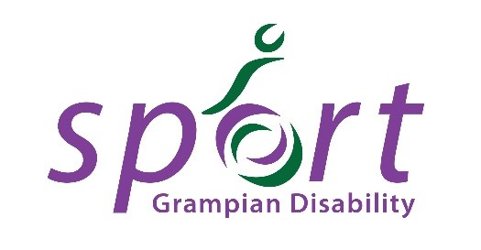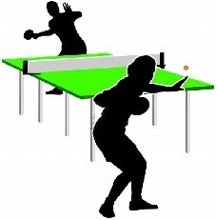
Grampian Games 2019
Saturday 25th & Sunday 26th May
For athletes with a physical, sensory or learning disability

Events:

Saturday 25th May
Boccia – 10am - 4pm
Table Tennis – 10am - 4pm
Aberdeen Sports Village - café open all day

Sunday 26th May
Swimming 12pm – 3.30pm
Inverurie Swimming Pool

10-Pin Bowling 10am - 3pm
Indoor Bowls 6pm - late
Garioch Indoor Bowling Centre - café open until 7pm

Entry forms can be acquired by contacting Alison Shaw, Regional Manager, Scottish Disability Sport, Broadfold House, Bridge of Don, Aberdeen, AB23 8EE and must be returned via email or post by 10th May 2018.

Alison can be contacted on alison.shaw@scottishdisabilitysport.com or 07828 744 848 for entries and cancellations.

Ten Pin Bowling Competition for Players with a Physical, Sensory or Learning Disability

Sunday 26th May 2019
10am - 3pm
Garioch Indoor Bowling Centre

COMPETITION RULES

- There will be two sections of the competition:

A Senior players over the age of 16 (any disability)

B Junior players under the age of 16 (any disability)

(the organiser reserves the right to combine categories if entries in some categories are low)

- The competition will use the knockout system, numbers dependent, if we get an unexpectedly high number of entrants then a highest score wins system across all the lanes will be used.

- All matches will be last for 10 frames, if there are a great number of entries, then matches will be time limited.

- ENTRY FEE

The entry fee will be £5.00 per person. Cheques should be made payable to “Grampian Disability Sport".

5 For any cancellations, please let us know in advance by contacting Alison on alison.shaw@scottishdisabilitysport.com or 07828 744 848

GRAMPIAN GAMES CONSENT FORM TEN PIN BOWLING

Name of participant:…………………………………………………………………………………………………………..
Please tick (√) category:
 Group A Senior players over the age of 16 (any disability)
 Group B Junior players under the age of 16 (any disability)

Male/Female:…………………… Age: ............. Name of School: (if applicable) .....................................................
Parent/Carer’s Name: ...........................................................................................................
Contact No. ............................................ Email: ................................................................................................
Will a carer accompany the participant to the session? (Please circle) YES / NO
If no, please give the name of someone we can contact during the time of the session in case of emergencies.
Name: ...................................................................... Contact No. .....................................................................
Please use the space below to share further information about your disability you feel we may need to know to provide the best sporting experience for you. Please inform if you use a wheelchair or assisted devices.

………………………………………………………………………………………………………………………………………………………………………
Please indicate any special medical needs you may have that we should know about e.g. Asthma, Epilepsy

………………………………………………………………………………………………………………………………………………………………………
Please indicate any special educational needs you may have you would wish to make us aware of:

………………………………………………………………………………………………………………………………………………………………………
If you use sign language or have a special need relating to communication please state below and elaborate as fully as possible (e.g. do you use Makaton)

………………………………………………………………………………………………………………………………………………………………………
Do you consent to receiving first aid/medical treatment? (please circle) YES NO
Photography may be used during the sessions. Images will be used in publications and on our website to publicise our services or celebrate special events. These may also appear in our printed publications, on our website, intranet, social media ie facebook, twitter and on Plasma screens in various council offices. We may also send them to the news media.
I DO CONSENT/DO NOT CONSENT to the participant being photographed and images used as indicated above (please delete as appropriate)
Data Protection
Please sign below to confirm that you have read and understood our Privacy Notice, which can be viewed on our website here: http://www.grampiandisabilitysport.org.uk/documentation/

Signature ........................................................................ Relationship .................................
Please include your email address if you would like to be added to our emailing list to be the first to hear about new clubs, events and training opportunities.
Email: ................................................................................................................................................................
Grampian Games Athlete Code of Conduct – Ten Pin Bowling

Aim: To ensure that all athletes/coaches involved with G.D.S. participate within an agreed philosophy and set of standards.

Principle Statement of Ethics

Sporting integrity is based on the acceptance of rules, fairness, equality, respect for others, moral conduct and a sense of what is right. The goal of G.D.S. is to create a sporting environment where violence, breaking the rules, the abuse of drugs, the lack of fair play and other unethical behaviour are automatically rejected as being irrelevant to the true purpose of sport.

I the athlete/coach agree to the following:

- to abide by the principle statement on Ethics above
- practice and play within the spirit of the game
- help each other to learn new skills
- compete as a team
- respect others – coach, officials, other players, team managers, parents who help organise/play the sport
- do not direct verbal, physical, emotional abuse towards opponents/coaches/umpires/event organisers & other team members
- treat all others as you would like to be treated, with integrity and respect
- arrive before the start of each session to ensure adequate preparation and to be punctual on all occasions, where possible provide information in advance if you are ill or unable to attend any session.
- set a good example at all times in aspects of dress, language, behaviour, and respect of equipment and others.

Signature: ......................................................... Date: ......................................

