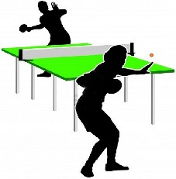
Grampian Games 2019
Saturday 25th & Sunday 26th May
For athletes with a physical, sensory or learning disability

Events:

Saturday 25th May
Boccia – 10am - 4pm
Table Tennis – 10am - 4pm
Aberdeen Sports Village - café open all day

Sunday 26th May
Swimming 12pm – 3.30pm
Inverurie Swimming Pool

10-Pin Bowling 10am - 3pm
Indoor Bowls 6pm - late
Garioch Indoor Bowling Centre - café open until 7pm

Entry forms can be acquired by contacting Alison Shaw, Regional Manager, Scottish Disability Sport, Broadfold House, Bridge of Don, Aberdeen, AB23 8EE and must be returned via email or post by 10th May 2018.

Alison can be contacted on alison.shaw@scottishdisabilitysport.com or 07828 744 848 for entries and cancellations.

