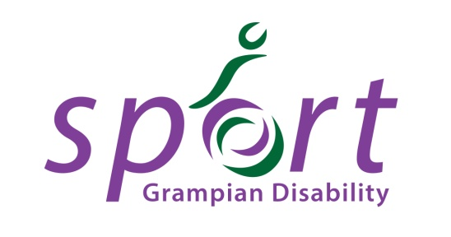

Affiliation of Individuals, Clubs, Organisations & Schools

Grampian Disability Sport (GDS)
GDS is committed to lead in the development of sport for people with physical, sensory or learning disability in partnership with key local agencies in the three local authority areas of Aberdeen City, Aberdeenshire and Moray.

Affiliation
GDS invites individual athletes with a disability, and individuals, organisations, schools and clubs who currently work with (or are looking to work with) people with disabilities to become affiliated to GDS. This serves to ensure quality standards within disability sport provision across the region whilst enabling us to support athletes and the people who work with them in their sporting careers.

Benefits of Affiliation
- Ability to obtain tailored advice and support regarding sport provision, coaching, legislation, classification, competitions and many more aspects of disability sport.
- Representation of yourself, or school, club, sport and/or organisation at GDS Committee Meetings.
- Opportunity to represent GDS at local, regional and national Scottish Disability Sport events.
- Opportunity to be kept informed of developments in the disability sport sector including CPD opportunities, award nomination opportunities etc through the GDS mailing list.
- Eligibility to apply for funding from GDS towards specified competition and CPD costs (excluding schools or Organisations/Clubs who opt out of funding), and advice and support regarding external funding sources.
- Free of charge use of meeting space.

Eligibility
- Applications are accepted from schools, clubs, organisations and individuals residing within the Aberdeen City, Aberdeenshire or Moray boundaries who are currently or seeking to be involved in disability sport.
- Clubs, organisations and independent schools must have the following documentation in place to be considered for affiliation:
  - A constitution or equivalent.
  - An equal opportunities policy or equivalent.
  - A health and safety policy covering accidents, first aid, incidents and emergency evacuation.
  - A Protecting Vulnerable Groups policy or equivalent (Safeguarding Policy) for schools and organisations working solely with under 18’s).
  - PVG Scheme Membership for all teachers, lead coaches, group leaders etc.
- For organisations with multiple ‘Clubs’ and ‘Sessions’ running under the organisation’s banner, only one application for affiliation is required.

Costs
- Schools: Free of charge
- Organisations and Clubs (access to funding applications): £20 per annum
- Organisations and Clubs (no access to funding applications): Free of charge
- Individuals: £5 per annum

Funding
For information about whom and what GDS may be able to provide funding for, please see the separate funding guidelines & application document.

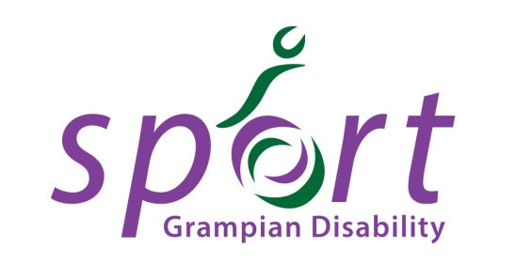

Affiliation Form

Name of Applicant:

Name of School/Club/Organisation (where applicable):

Contact Address:

Postcode:

Contact Telephone Number:

Contact Email Address:

Type of Application (please tick one option only):
    - Individual (£5)
    - School (Free)
    - Club or Organisation – Access to Funding Applications (£20)
    - Club or Organisation – No Access to Funding Applications (Free)

Sports or Activities you are/your organisation is involved in:

Number of people with disabilities participating in your activities (Clubs, Schools & Organisations only):

Type of disability you have (Individuals only):

Types of disability your Club/School/Organisation caters for (Clubs, Schools & Organisations only):

What aspect of GDS’ service encouraged you most to apply for affiliation?

Signed: ___________________________________________
Print Name: ___________________________________________
Date: ___________________________________________

Please note that affiliation applications can take up to 28 days to process. We will inform you of the outcome of your application by email or phone.

Please complete and return your affiliation form to Grampian Disability Sport, Craigievar House, Howe Moss Avenue, Dyce, Aberdeen, AB21 0GP or info@grampiandisabilitysport.org.uk

General Data Protection Regulation

- The information gathered on this form will be used to provide sporting opportunities and will provide you with information on other activities & events we think may be of interest to you and your child/ren.

- These details will be held by Scottish Disability Sport and will be shared by the local authority, Active Schools partners in Grampian (Aberdeen City, Aberdeenshire & Moray) and with sportscotland where appropriate. The information given will be treated in confidence and held in accordance with the requirements of data protection legislation.

- Please indicate whether you are happy for this information to be shared as described? Yes No

- A full copy of our privacy notice can be seen on our website, www.scottishdisabilitysport.com/privacy-notice. If you would like a printed copy please contact Scottish Disability Sport on 0131 317 1130 or email admin@scottishdisabilitysport.com

- Please confirm that you have read and understood our privacy notice: Yes

