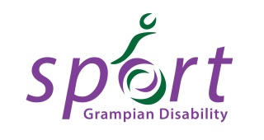
Grampian Disability Sport
Online Activity Directory

Grampian Disability Sport is currently developing their online directory of disability sport opportunities across the region. If you wish your club or organisation’s activities to be listed in the online directory of activities, please complete this form for each activity/session you deliver and return it to Alison Shaw, Scottish Disability Sport Regional Manager on alison.shaw@scottishdisabilitysport.com.
Please contact Alison on 07828 744848 with any queries you have.

Please also send a photograph or photographs of your sport / session to be used alongside your listing in the directory. Please note that you must have photographic consent for everyone in the photograph.

Session Name
Sport
Club or Organisation running the activity
Is your club or organisation affiliated to a National Governing Body of Sport, if so which one?
Venue
Day
Time
Contact person
Contact number
Contact email address

Brief description of the activity

Is your activity open to:  (please highlight all that apply) | Adults (over 18 years)  Juniors (under 18’s)  Athletes with a physical disability  Athletes with a sensory impairment  Athletes with a learning disability  Athletes with autistic spectrum disorder
Any additional information that may be useful
Website address if you have one
Social media links if you use these
Current number of participants (this is useful for us to know but won’t be printed in the brochure)

