

RULES & INFORMATION
Scottish National Junior Athletics Championships 2019
Wednesday 5 June 2019

Grangemouth Stadium
Kersiebank Avenue
Grangemouth
FK3 0EE

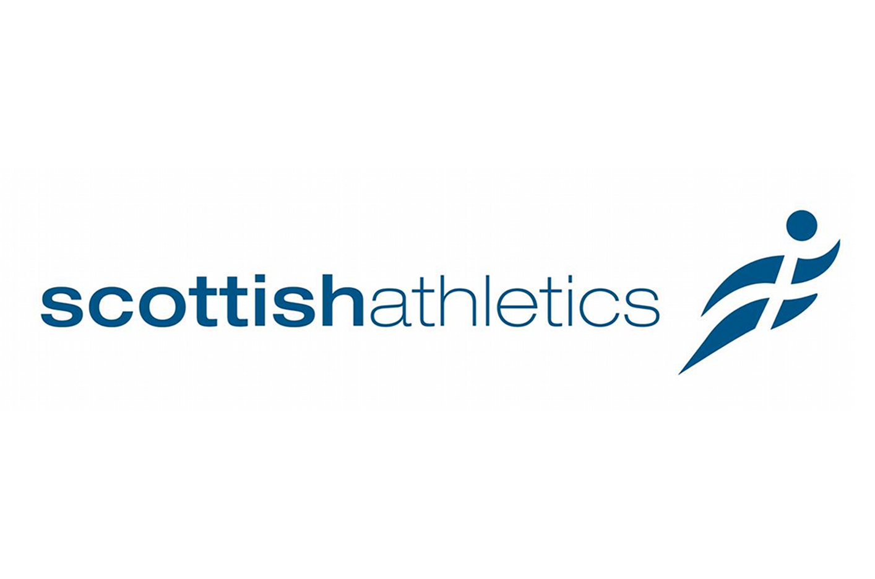

Leading the development of sport in Scotland for people of all ages and
abilities with a physical, sensory or learning disability

23 April 2019
To: Branch Representatives/School contacts

From: Norma Buchanan, Administrator, SDS

Entries are invited for the following National Event:

S.D.S. OPEN JUNIOR ATHLETICS CHAMPIONSHIPS FOR ATHLETES

OF SCHOOL AGE WITH A PHYSICAL DISABILITY, SENSORY

IMPAIRMENT AND/OR LEARNING DISABILITY

WEDNESDAY 5 JUNE 2019

Grangemouth Stadium, Kersiebank Avenue, Grangemouth FK3 0EE

10.30 hrs – 16.00 hrs
Check in – 10.00 hrs

CLOSING DATE FOR ENTRIES: WEDNESDAY 15 MAY 2019

Please find enclosed rules, classification detail and entry form on separate excel document. Invoice and Team Profile to be completed and returned to Norma.

Please note SDS Privacy Policy.

The event will start at 10.30 hrs SHARP. Team managers should check in by 10.00 hrs with a list of withdrawals or changes.

There is an entry fee of £4.00 per competitor. All cheques should be made payable to S.D.S. and send to the Norma Buchanan, Administrator, SDS, Michael Woods Sports Centre, Viewfield, Glenrothes, Fife KY6 2RD

If paying by BACS please inform Norma by email with details of the amount and date transferred

Details for making an online payment to Scottish Disability Sport is as follows:
Account Name: Scottish Disability Sport
Bank: Royal Bank of Scotland
Account Number: 1007 2189
Account Sort Code: 83 19 04
Please put surname and the event as the reference when making the payment i.e. Munro Scot Boccia

Children who only have behavioural or emotional difficulties are not eligible to compete.

EVENTS - Athletes may enter a maximum of 3 events.

TRACK - 50M, 100M, 200M, 400M, 800M, 1500M (for ambulant, wheelchair racers and Running bikes)
100M Walk (for ambulant athletes that cannot run), Power Chair Slalom and 60M

FIELD - Long Jump, Standing Long Jump, Shot Putt, Softball, Javelin and Discus

Club (for wheelchair users only that cannot throw a shot putt), Bean Bag Distance throw (for athletes who use a power chair and cannot do a club)

There is a small café at Grangemouth Stadium but athletes/escorts are advised to bring a packed lunch. There will be a short lunch break if time permits.

It is hoped to finish no later than 16.00 hours.

Please complete and return the entry form to Norma Buchanan, Administrator S.D.S., Michael Woods Centre, Viewfield, Glenrothes, Fife KY6 2RD (email norma.buchanan@fife.gov.uk ) no later than Wednesday 15 May. It is hoped that SDS Branches will co-ordinate entries on behalf of local athletes but individual entries will be accepted from those who are not members of a branch. It is also hoped that Branches will circulate to all interested parties in their area. Please photocopy entry forms as required.

If you have any queries or require directions to Grangemouth please do not hesitate to contact Mark Gaffney –(07966388957 ), Janice Eaglesham (07712 624498), or myself at the S.D.S. Fife office.

Norma Buchanan
Administrator, SDS

PHOTOGRAPHY

Photography and / or video footage may be taken on the day to use for SDS funding, promotional or publicity purposes. SDS will retain full rights to these images for use which includes (but is not restricted to) the right to use them in their printed and online publicity, social media, press releases and funding applications.

Should there be any member of your team who does not wish to consent to their images being used please provide their name(s) below and arrangements will be made appropriately.

Name(s) of team members who do not wish their images to be used.

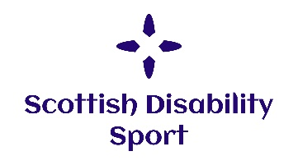
Scottish Disability Sport Privacy Notice
Scottish Disability Sport is a “controller” of the personal information you provide to us.

What we need
When you provide information about yourself for events, courses, workshops or other opportunities, we will ask you for the following information:
- Contact details including name, address, telephone number, email address and date of birth;
- Details of your role in sport, e.g. coach, athlete, volunteer, official, parent, support staff;
- Equality information including age, disability or medical condition, employment information, ethnic group, religious belief, gender identity and sexual orientation.

Why we need your personal information

Contractual purposes
We need to collect personal information in order to manage attendance and participation. We will use this information to:
- Provide you with services such as training or activities;
- Administer your attendance;
- Process awards and qualifications;
- Send you communications in relation to opportunities we think may interest you.
If you do not provide all of the personal information we request then this may affect our ability to offer you services and benefits.

Legitimate purposes
We also process personal information in order to:
- Promote and encourage participation in disability sport by sending communications about forthcoming opportunities. Our events may be photographed or filmed and information captured in this way may be used for promotional and education purposes. You will always be given the option to refuse this;
- Provide opportunities and competition in disability sport by managing entries for events and checking your personal information to ensure you are participating at an appropriate level;
- Monitor and develop participation in disability sport by monitoring engagement and participation and, on occasion, inviting participants to take part in surveys for research and development purposes;
- Develop and maintain qualifications and awards, including sending communications to inform you of forthcoming courses, renewal requirements and to verify that you have completed any mandatory training requirements;
- Respond to and communicate with participants regarding questions, comments, support needs or complaints in relation to disability sport.
Where we process your personal information in pursuit of our legitimate interests, you have the right to object to us using your personal information for these purposes. If you wish to object to any of these, please contact Scottish Disability Sport on 0131 317 1130, email admin@scottishdisabilitysport.com or write to us at Caledonia House, South Gyle, Edinburgh EH12 9DQ.

Legal obligations
We are under a legal obligation to process certain personal information for the purposes of complying with:
- The Protection of Vulnerable Groups (Scotland) Act 2007 to check that our coaches and volunteers are able to undertake regulated work with children and vulnerable adults;
- Our sportscotland regulatory requirements to report on size, achievements and profile;
- The Equality Act 2010, which requires us to process personal information to make reasonable adjustments where necessary.

Equality monitoring requirements
We are required by sportscotland to use personal information relating to equality for monitoring purposes.
We will process such personal information through aggregated and anonymised reports to identify and keep under review equality of opportunity or treatment of groups of people, to promote or maintain equality within disability sport.

Other uses of personal information
We may ask you if we can process your personal information for additional purposes. If so, we will provide you with additional information on how we will use your information.

Who we share your personal information with
If your personal information is included in any images or videos we take, we may share this with event or project partners or governing bodies, including sportscotland, for promotional purposes.
We may be required to share personal information with statutory or regulatory organisations, such as Disclosure Scotland or Police Scotland.
We may also share personal information with our professional and legal advisors in order to take advice.
Where we share personal information with third parties, we will only share the personal information strictly required for the specific purposes and will take reasonable steps to ensure that recipients shall only process the disclosed personal information in accordance with those purposes.
We may employ contractors to process personal information. Such contractors are subject to written contracts to only process that information under our instructions, to process and to abide by the restrictions of existing legislation on data protection.

How long we keep your personal information
We will only keep your personal information for as long as necessary or for as long as we believe you to maintain an interest in disability sport.
We will keep certain personal information for longer in order to confirm your identify.

Your rights
You can exercise any of the following rights by contacting Scottish Disability Sport on 0131 317 1130, email admin@scottishdisabilitysport.com or write to us at Caledonia House, South Gyle, Edinburgh EH12 9DQ:
- The right to request access to the personal information we hold about you by making a “subject access request”;
- The right to have personal information corrected or completed;
- The right to request that we restrict the processing of your personal information for specific purposes;
- The right to request us to delete your personal information.
Any requests received by Scottish Disability Sport will be considered under data protection legislation. If you remain dissatisfied, you have a right to raise a complaint with the Information Commissioner’s Office at www.ico.org.uk.

SCOTTISH DISABILITY SPORT

OPEN JUNIOR ATHLETICS CHAMPIONSHIPS FOR ATHLETES OF SCHOOL AGE WITH A PHYSICAL DISABILITY, SENSORY IMPAIRMENT AND/OR LEARNING DISABILITY

Wednesday 5 June 2019 – Grangemouth Stadium

Closing date for entry – Wednesday 15 April 2019

Entries e-mailed to:
SDS MEMBER BRANCHES
ANGUS | LAURA SMITH | Laura.ap.smith@angusalive.scot
AYRSHIRE | DIANE CAMPBELL | admin@ayrshiresportsability.org.uk
BORDERS | ALAN OLIVER | aoliver@liveborders.org.uk
D&G | LAURA VICKERS | laura.vickers@dumgal.gov.uk
DUNDEE | GORDON QUINTON | gordon.quinton@leisureandculturedundee.com
FIFE | NORMA BUCHANAN | Norma.Buchanan@fife.gov.uk
FORTH VALLEY | GRAHAM HARVEY | graham.harvey@fvds.org.uk
GLASGOW | GILL WILSON | gill.wilson@glasgowdisabilitysport.org
LOTHIAN | JACK BRODIE | admin@lothiandisabilitysport.co.uk
P&K | GRAEME DOIG/ STEPH REID | enquiries@perthandkinrossdisabilitysport.com
S. LANARKSHIRE | MARION WOTHERSPOON | Marion.Wotherspoon@southlanarkshireleisure.co.uk
SDS REGIONAL MANAGERS
CENTRAL | CHERYL LAPPIN | Cheryl.lappin@scottishdisabilitysport.com
EAST | NEAL HERBERT | neal.herbert@scottishdisabilitysport.com
FIFE | RICHARD BRICKLEY | Richard.brickley@scottishdisabilitysport.com
GRAMPIAN | ALISON SHAW | Alison.shaw@scottishdisabilitysport.com
HIGHLAND | KIRSTY EWEN | kirsty.ewen@scottishdisabilitysport.com
TAYSIDE | GRAEME DOIG | graeme.doig@scottishdisabilitysport.com
WEST
WEST | LYNN ALLISON | Lynn.allison@scottishdisabilitysport.com

