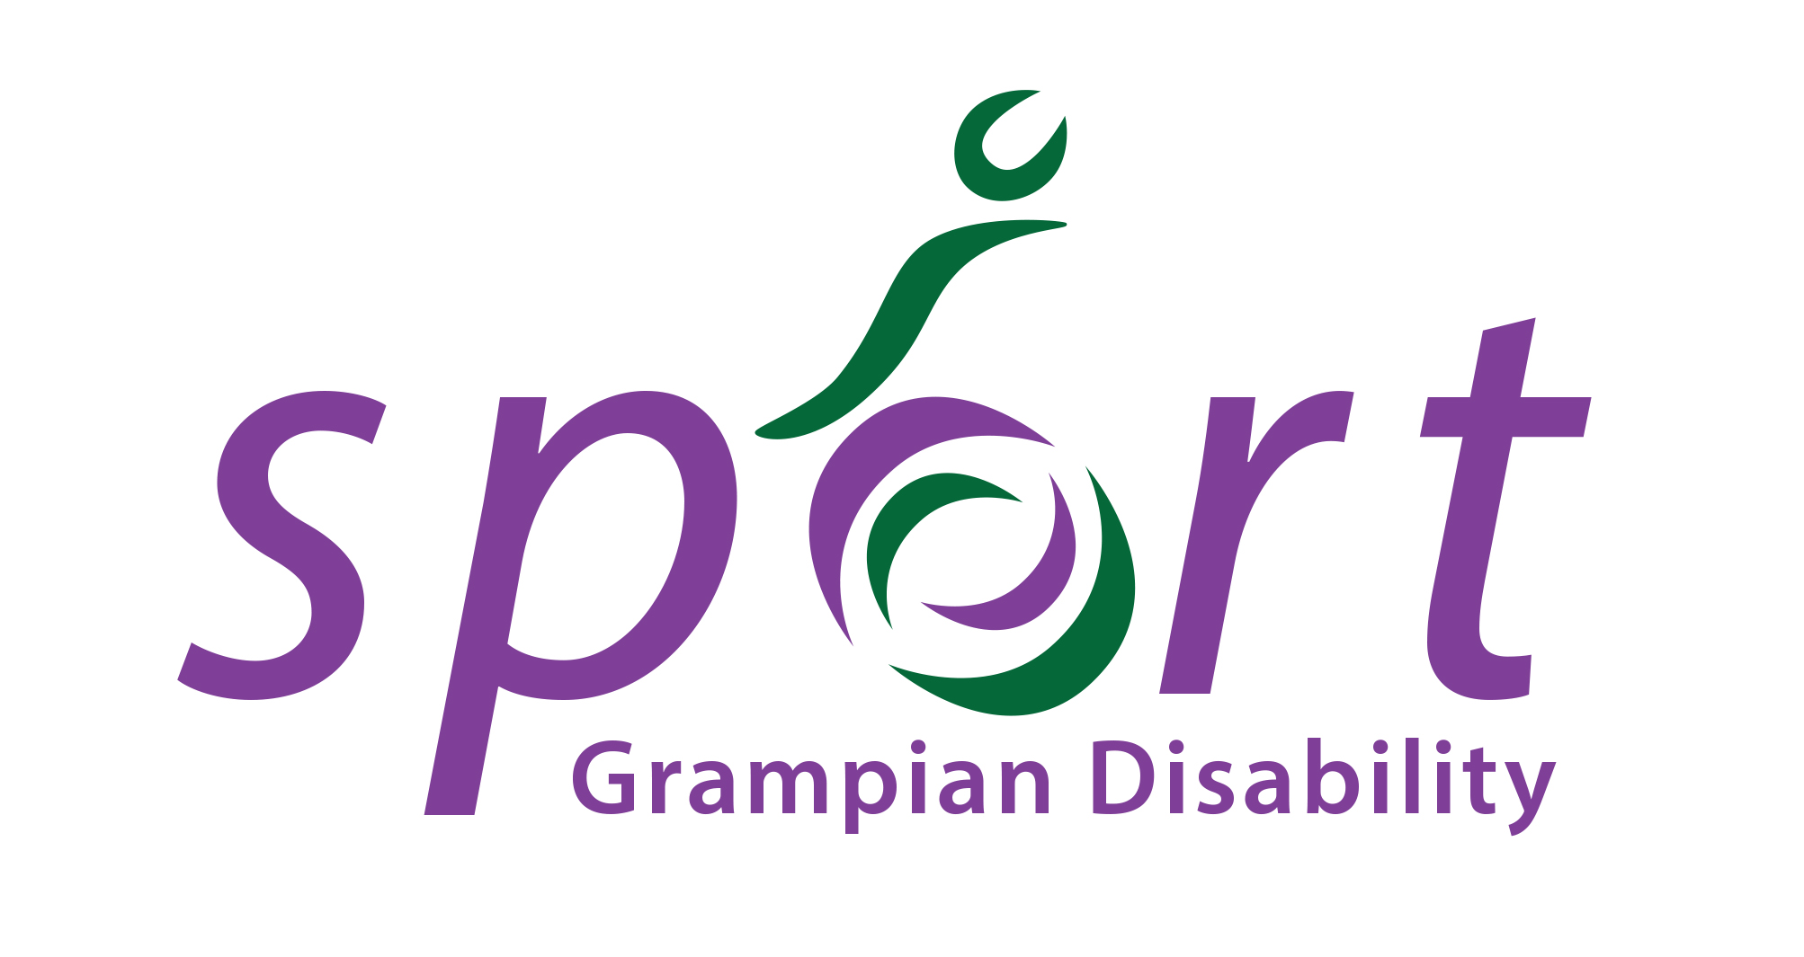
Grampian Disability Sport: Chair Person

Recruiting body: Grampian Disability Sport
Closing date: Wednesday 15th June 2022

Grampian Disability Sport (GDS) is a voluntary group where the main aim is to lead in the development of sport for people with physical, sensory or learning disabilities in partnership with key local agencies and local authority areas in Aberdeen City, Aberdeenshire and Moray. GDS is a member branch of Scottish Disability Sport (SDS) who are the governing body of sport for athletes and players with a physical, sensory or learning disability. GDS have achieved SDS Minimum Operating Requirements (MOR) which ensures all governance is up to date and appropriate. The committee of GDS now wishes to appoint new chair to continue the growth and development of the Branch. We welcome applications from people of all walks of life, and experience in sport is not necessary.

Contract – This is a voluntary position, but all reasonable expenses will be paid. The Chair Person will be expected to attend Branch meetings (held 10 - 12 times per year), support the Branch to maintain SDS Minimum Operating Requirements and support the committee in driving the Branch forward. The level of time commitment is flexible and will be tailored to suit the applicant’s current commitments and the needs of the branch.
Term – 2 years

ROLE TITLE: | Chair Person
RESPONSIBLE TO: | Grampian Disability Sport Committee
SKILLS REQUIRED: | - Enthusiastic  - Well organised  - A passion for making a difference to the lives of people with disabilities  - Prepared to make a regular time commitment  - PVG Scheme Member  - Prepared to make confident decisions when necessary  - Able to exert competent leadership skills
MAIN DUTIES:

- To lead Grampian Disability Sport (GDS) to fulfil its responsibilities for the governance of the organisation by ensuring that the charity acts in accordance with its constitution and by managing its activities.

- To be a strategic lead for the organisation and ensure that the objectives of the development plan are met.

- To optimise the relationship between GDS and its staff/volunteers.

- Take responsibility for managing the executive committee and the affairs of GDS. Oversee and guide all decisions taken by the committee and sub committees.

- In liaison with the committee and partners, oversee the work of all officers.

- In conjunction with the secretary, prepare and present the annual report.

- Liaise with the secretary on the agenda for each meeting and approve the minutes before they are circulated.

- Be completely familiar with the constitution, committee procedures and the NGB rules and regulations.

- Liaise with the Treasurer to ensure that funds are spent properly and in the best interests of GDS and its affiliates.

- Help to prepare and submit any statutory documents that are required in conjunction with the committee (e.g. OSCR returns, grant aid reports).

- If unable to attend any committee meeting, a written report should be sent to the meeting and the Vice Chair briefed on the Agenda.

Interviews
TBC

Applications
All applicants should send a note of interest to alison.shaw@scottishdisabilitysport.com detailing why you are interested in the role and any relevant skills and experience.
If you have any questions or would like more information, please contact Alison Shaw on the above email or phone 07828 744 848.

