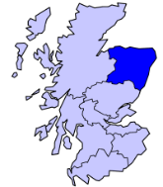
Grampian
Parasport Festival

Friday 16th September 2022

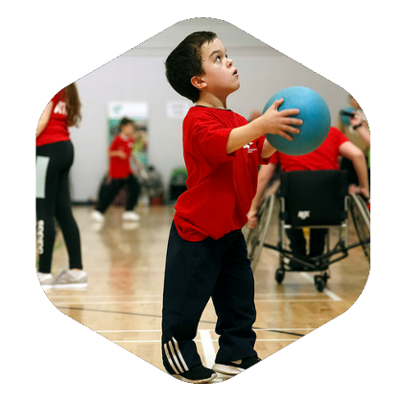

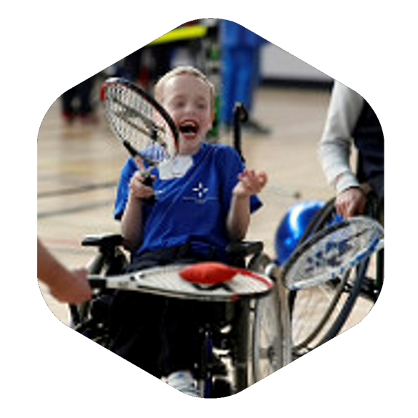

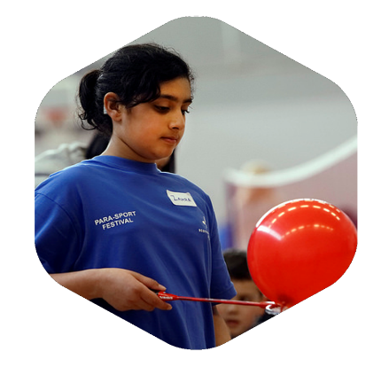

Aberdeen Sports Village & Aquatics Centre
Regent Walk
Aberdeen, AB24 1SX

Introduction and Background
Scottish Disability Sport is delighted to be returning for our 9th Grampian Parasport Festival in partnership with Active Schools, North East Scotland College, and regional community sports clubs, thanks to generous funding from the Scottish Government’s Communities Mental Health & Wellbeing Fund.
The Parasport Festival is designed to introduce pupils from mainstream education with a physical disability, vision impairment or hearing loss from across Moray, Aberdeenshire & Aberdeen City to try new and exciting sports. The groups identified above are significantly under-represented when it comes to participating in weekly sport or physical activity. After the event, the Scottish Disability Sport regional manager Alison Shaw will make contact to share local opportunities, pathways available and support transition into weekly participation.
Please use this link to watch our ‘Get Involved’ video go find out a bit more.
Event Details
Registration will take place between 09:45 – 10:00.
The event will start promptly at 10:00 and finish at 15:00.
Address: Aberdeen Sports Village, Regent Walk, Aberdeen, AB24 1SX
Sports include* Boccia, Badminton, Judo, Football, Powerchair Football, Athletics, Wheelchair Basketball, Table Tennis, Swimming and Kayaking. These sports will be delivered by some of the best clubs and coaches available in Grampian.
*sports offered to your child from this list will be determined by their age and disability type.

Planning for The Day

Refreshments
There are cafés at the Sports Centre and Aquatics Centre but you are more than welcome to bring a packed lunch with you. You should also bring a water bottle, which can be refilled on-site.
What should my child wear?
Please wear clothes and appropriate footwear suitable for participation in indoor physical activity and sport. Bring swimwear and a towel for the water sports sessions.

Can a parent/carer attend too?
Yes, we encourage parents and carers to attend where possible. Children who need support with changing and personal care will need to have a carer/parent with them. There is a parent & carer workshop on offer in the afternoon where you can meet others and find out more about disability sport.

What do we do when we get there?
There will be a registration desk set up in the main entrance where you can sign in for the event. You will be directed to your group, and your Group Leader will stay with you throughout the event to guide you. You will be given your group timetable for the day and a Parasport Festival t-shirt to keep.

Parking
Ample accessible parking is available at both the Aquatics Centre and the Sports Centre (which is located on Linksfield Road). There is no charge for parking.

Accessible Toilets and Changing
There are accessible changing facilities throughout the facility including a Changing Places facility at the Aquatics Centre, and a changing room with a ceiling track hoist & a fixed height changing bench in the Sports Centre café.

Equipment
All sport-specific equipment will be provided by the clubs.

First Aid
Aberdeen Sports Village have qualified first aiders on-site at all venues.

Cost
There is no cost to enter or participate in this event.

Application Deadline
The closing date for entries is Monday 12th September 2022

What if I have more questions?
Please contact Alison Shaw, Regional Development Manager for Scottish Disability Sport, at alison.shaw@scottishdisabilitysport.com or call 07828 744 848.
How to apply
Please register for the festival on the link below.

https://sds.justgo.com/workbench/public/events?ref=96FD7D19BD9D634541ABDE64788E2309D1326174
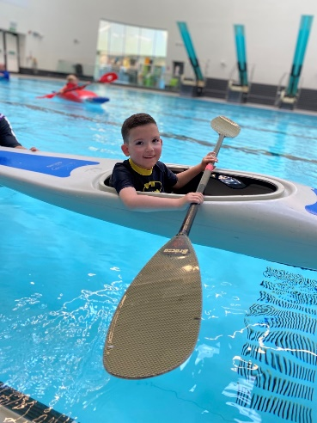
Or
Complete the form below and email it to: alison.shaw@scottishdisabilitysport.com
“I had the best day ever”
Tyler

“Omg Alison! What an event! We are well and truly blessed to have been part of it. Thanks so much for having us and we hope we can get to come along to the next one…his smiling and laughter and happiness has made my heart so full!”
Caelsa, Tyler’s Mum

Tyler – Age 7

Social Media
It would be greatly appreciated if you could highlight your or your child’s involvement at the event across social media. As part of this, we would be grateful if you could tag Scottish Disability Sport:
Scottish Disability Sport
@SDS_sport
#InspiringThroughInclusion

Guidelines for Pupil Eligibility
Below is a set of guidelines for pupils who are eligible to take part in the Parasport Festival. Please note these lists are not exhaustive, however they do provide a guide. Please contact Alison Shaw if you have any queries – alison.shaw@scottishdisabilitysport.com. If your child is ineligible for the Parasport Festival but you would like to find out more about sporting opportunities for your child, please also get in touch with Alison.
Physical Disability
- Achondroplasia (dwarfism) | - Multiple Sclerosis
- Amputees (including dysmelia)  - Arthrogryposis  - Brittle Bones  - Cerebral Palsy  - Legge-Perthes | - Muscular Dystrophy  - Polio  - Spina Bifida  - Spinal Cord Injury

Deaf/Hearing Loss
Sensory disability relates to an impairment to one (or more) of the senses. An individual may have no hearing (deaf) or a mild loss of their hearing. Some examples include:
• Tinnitus
• Otosclerosis
• Stickler Syndrome
Blind/Vision Impairment
Sensory disability relates to an impairment to one (or more) of the senses. An individual may have no sight (blind) or a mild impairment to their sight.
Some examples include:
• Tunnel vision
• Cortical visual impairment

There are a number of conditions for which this event is NOT available:
- ADHD | - Epilepsy
- Asperger’s Syndrome | - Haemophilia
- Asthma | - Hydrocephalus
- Autistic Spectrum | - Obesity
- Cystic Fibrosis  - Diabetes  - Dyspraxia | - Scoliosis  - Transplants  - Downs Syndrome  - Learning Disability
If your child’s primary disability is listed in the eligible conditions, but they also have one of the above conditions, please contact Alison who will be able to determine if the event will be suitable for your child. Alison.shaw@scottishdisabilitysport.com or 07828 744 848.

Application Form
Participant Details
Name
Date of Birth
Address
Postcode
Mainstream School
Disability  (Please Tick) | Physical Disability  Vision Impairment  Hearing Loss
Gender
Ethnicity
Mobility Equipment Used
(e.g. manual wheelchair, powerchair)
Please provide information about your disability that you feel we may need to know in order to provide the best experience for you, including the names of all disabilities your child has.
Is your child able to swim unaided?
Parent / Guardian Contact Details
Name
Relationship to Participant
Telephone Number
Email
Emergency Contact Details (if different)
Name
Relationship to Participant
Telephone Number

Sporting Activities
We aim to gather information to measure the impact this event has on participants’ level of physical activity – to do so, can you please complete the required information below?
We may contact you after the event to ask whether levels of activity have been increased as a result of attending the event.
In a typical week over the last month, how many days was your child physically active for 60 mins or more?
0 1 2 3 4 5 6 7
What is / are your child’s main reason(s) for taking part in sport / physical activity?

To get more active / fitter / healthier
To learn new skills
To lose weight
To increase confidence
To socialise / get out more/ meet people
Other reason(s)
…………………………………………………..
Does your child fully participate in PE in school?
Yes
No
If you would like to share information on your child’s PE participation, please use this box.

Is your child currently taking part in sport and physical activity?
Yes
No
If yes, please tell us the name of their club/session & whether this is a mainstream club, a disability-specific club or a session e.g. Active Schools

Photography
Photographers will be in attendance on the day to take photos of the children taking part in the Parasport Festival. On occasion we may use photographs for promotional materials.
Please tick the box if you do not wish your child to be photographed

T-Shirt Size
XS S M L XL

Will a Parent or Guardian be attending on the day? Yes / No
Would you like to attend the parent/carer information workshop at 1pm? Yes / No
Would you like to be kept informed of sport & physical activity opportunities for your child?
Yes/No

How did you come into contact with Scottish Disability Sport?

Physio Referral
Social Media/Website
School Referral
Previous Event/Parasport Festival
Word of Mouth

Branch Referral
Other
…………………………………………………..

Data Protection
The information gathered on this form will be used to provide sports opportunities on the day and provide you with information on other events we think may be of interest to you and your child/ren.
These details will be held by Scottish Disability Sport and will be shared by the local authority partners in the Grampian (Active Schools Aberdeen, Active Schools Moray & Active Schools

Aberdeenshire) and with sportscotland. The information given will be treated in confidence and held in accordance with the requirements of data protection legislation.
A full copy of our privacy notice can be seen on our website, www.scottishdisabilitysport.com/privacy-notice. A printed copy is included at the end of this document. Please contact Scottish Disability Sport on 0131 317 1130 for more information.
Please confirm that you have read and understood our privacy notice (see appendix below): Yes
Contact Details
For further information, please contact: Alison Shaw, Grampian Regional Development Manager, Scottish Disability Sport. alison.shaw@scottishdisabilitysport.com

We would like to express our gratitude to the following partners:

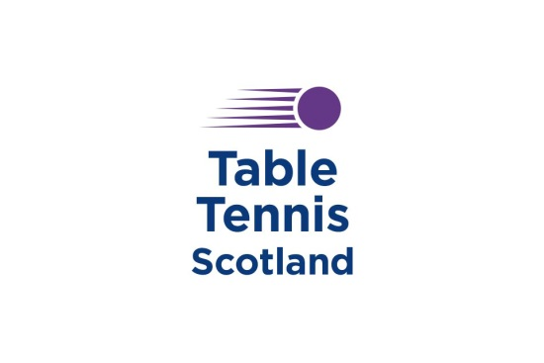
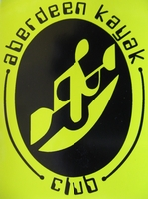
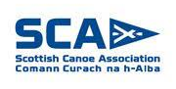
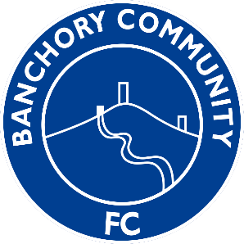
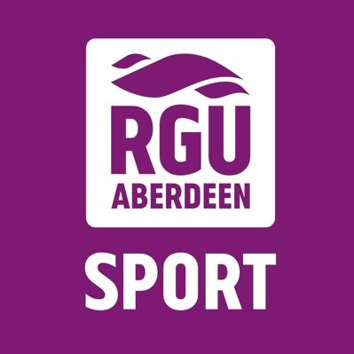
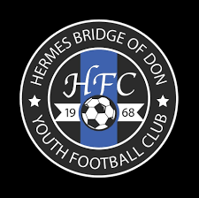
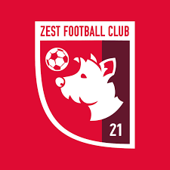

Scottish Disability Sport Privacy Notice
Scottish Disability Sport is a “controller” of the personal information you provide to us.

What we need
When you provide information about yourself for events, courses, workshops or other opportunities, we will ask you for the following information:
- Contact details including name, address, telephone number, email address and date of birth;
- Details of your role in sport, e.g. coach, athlete, volunteer, official, parent, support staff;
- Equality information including age, disability or medical condition, employment information, ethnic group, religious belief, gender identity and sexual orientation.

Why we need your personal information

Contractual purposes
We need to collect personal information in order to manage attendance and participation. We will use this information to:
- Provide you with services such as training or activities;
- Administer your attendance;
- Process awards and qualifications;
- Send you communications in relation to opportunities we think may interest you.
If you do not provide all of the personal information we request then this may affect our ability to offer you services and benefits.

Legitimate purposes
We also process personal information in order to:
- Promote and encourage participation in disability sport by sending communications about forthcoming opportunities. Our events may be photographed or filmed and information captured in this way may be used for promotional and education purposes. You will always be given the option to refuse this;
- Provide opportunities and competition in disability sport by managing entries for events and checking your personal information to ensure you are participating at an appropriate level;
- Monitor and develop participation in disability sport by monitoring engagement and participation and, on occasion, inviting participants to take part in surveys for research and development purposes;
- Develop and maintain qualifications and awards, including sending communications to inform you of forthcoming courses, renewal requirements and to verify that you have completed any mandatory training requirements;
- Respond to and communicate with participants regarding questions, comments, support needs or complaints in relation to disability sport.
Where we process your personal information in pursuit of our legitimate interests, you have the right to object to us using your personal information for these purposes. If you wish to object to any of these, please contact Scottish Disability Sport on 0131 317 1130, email admin@scottishdisabilitysport.com or write to us at Caledonia House, South Gyle, Edinburgh EH12 9DQ.

Legal obligations
We are under a legal obligation to process certain personal information for the purposes of complying with:
- The Protection of Vulnerable Groups (Scotland) Act 2007 to check that our coaches and volunteers are able to undertake regulated work with children and vulnerable adults;

- Our sportscotland regulatory requirements to report on size, achievements and profile;
- The Equality Act 2010, which requires us to process personal information to make reasonable adjustments where necessary.

Equality monitoring requirements
We are required by sportscotland to use personal information relating to equality for monitoring purposes.
We will process such personal information through aggregated and anonymised reports to identify and keep under review equality of opportunity or treatment of groups of people, to promote or maintain equality within disability sport.

Other uses of personal information
We may ask you if we can process your personal information for additional purposes. If so, we will provide you with additional information on how we will use your information.

Who we share your personal information with
If your personal information is included in any images or videos we take, we may share this with event or project partners or governing bodies, including sportscotland, for promotional purposes.
We may be required to share personal information with statutory or regulatory organisations, such as Disclosure Scotland or Police Scotland.
We may also share personal information with our professional and legal advisors in order to take advice.
Where we share personal information with third parties, we will only share the personal information strictly required for the specific purposes and will take reasonable steps to ensure that recipients shall only process the disclosed personal information in accordance with those purposes.
We may employ contractors to process personal information. Such contractors are subject to written contracts to only process that information under our instructions, to process and to abide by the restrictions of existing legislation on data protection.

How long we keep your personal information
We will only keep your personal information for as long as necessary or for as long as we believe you to maintain an interest in disability sport.
We will keep certain personal information for longer in order to confirm your identify.

Your rights
You can exercise any of the following rights by contacting Scottish Disability Sport on 0131 317 1130, email admin@scottishdisabilitysport.com or write to us at Caledonia House, South Gyle, Edinburgh EH12 9DQ:
- The right to request access to the personal information we hold about you by making a “subject access request”;
- The right to have personal information corrected or completed;
- The right to request that we restrict the processing of your personal information for specific purposes;
- The right to request us to delete your personal information.
Any requests received by Scottish Disability Sport will be considered under data protection legislation. If you remain dissatisfied, you have a right to raise a complaint with the Information Commissioner’s Office at www.ico.org.uk.

