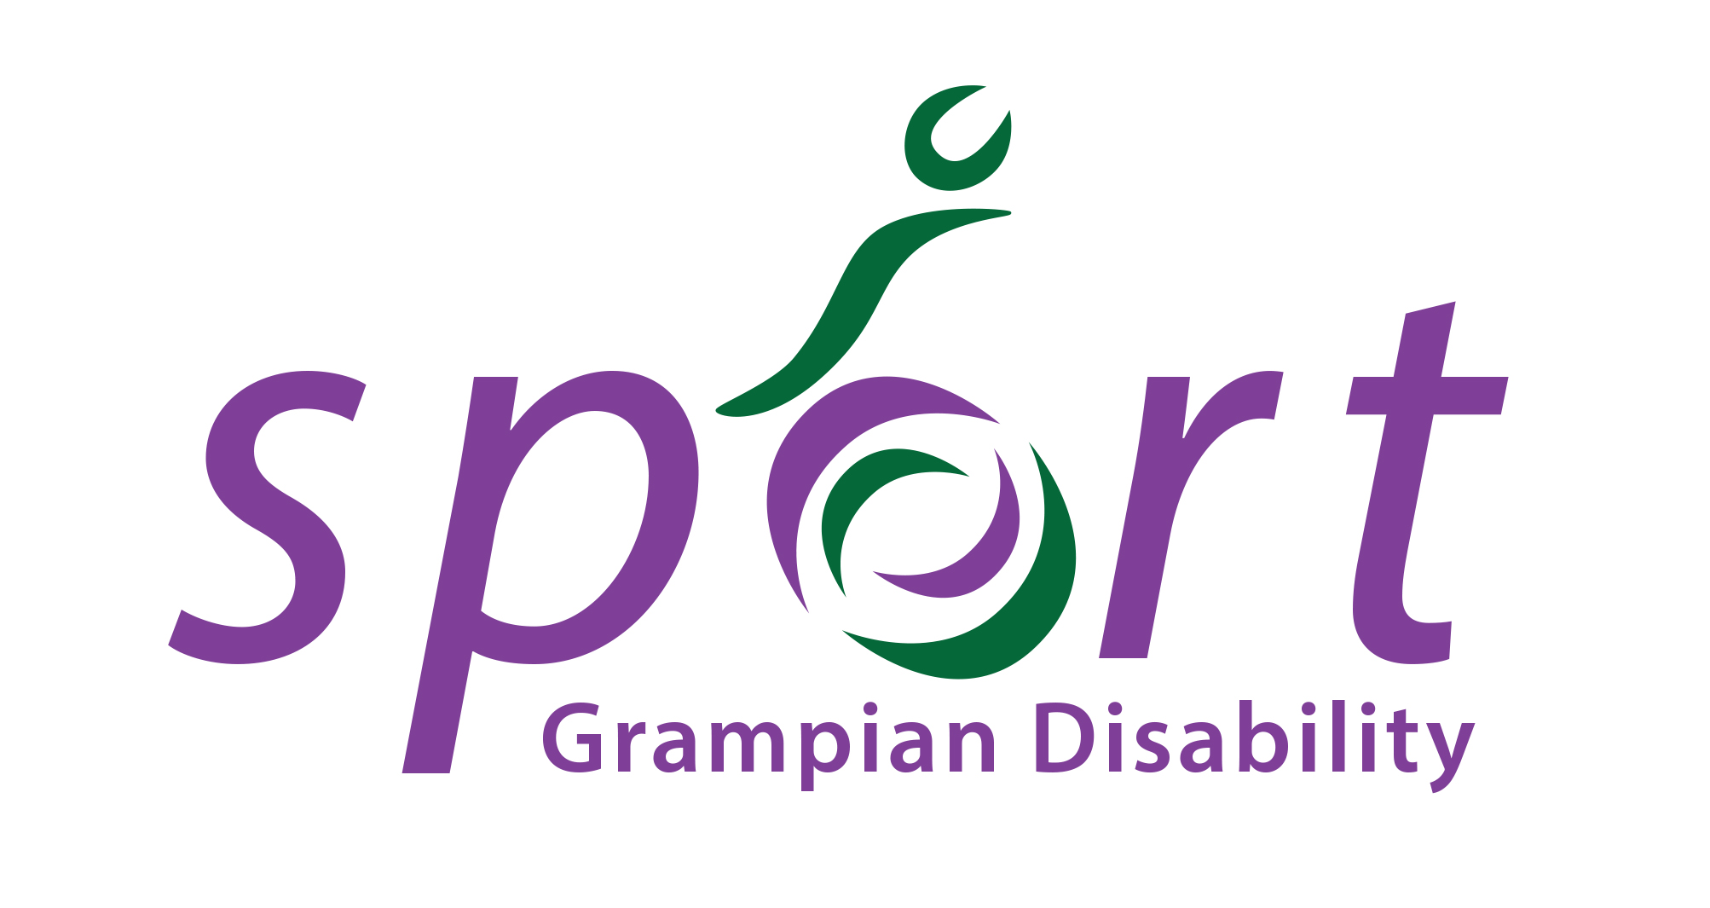
Grampian Disability Sport: Secretary

Recruiting body: Grampian Disability Sport

Grampian Disability Sport (GDS) is a voluntary group where the main aim is to lead in the development of sport for people with physical, sensory or learning disabilities in partnership with key local agencies and local authority areas in Aberdeen City, Aberdeenshire and Moray. GDS is a member branch of Scottish Disability Sport (SDS) who are the governing body of sport for athletes and players with a physical, sensory or learning disability. GDS have achieved SDS Minimum Operating Requirements (MOR) which ensures all governance is up to date and appropriate. The committee of GDS now wishes to appoint new Secretary to continue to ensure that our meetings and conducted in an organised and efficient manner

Contract – This is a voluntary position, but all reasonable expenses will be paid. The Secretary will be expected to attend and take minutes at meetings (10 – 12 per year), support the Branch to maintain SDS Minimum Operating Requirements and support the committee in driving the Branch forward. The level of time commitment is flexible and will be tailored to suit the applicant’s current commitments and the needs of the branch. We welcome applications from people of all walks of life, and experience in sport is not necessary.
Term – 2 years

JOB TITLE: | Secretary
RESPONSIBLE TO: | Grampian Disability Sport Committee
SKILLS REQUIRED: | - Good organisation skills  - Prepared to make a regular time commitment  - Enthusiastic  - Excellent written communicator  - Good listener

MAIN DUTIES:

- Committed to attending all management committees.
- Take minutes of meeting, complete and circulate before next meeting.
- In conjunction with the Chairperson, prepare and present the annual report
- Liaise with the chairperson on the Agenda for each meeting and approve the minutes before they are circulated
- Be completely familiar with Grampian Disability Sport policies and procedures, constitution, club rules and committee procedures.
- Help to prepare and submit any statutory documents that are required (e.g. VAT, grant aid reports)
- If unable to attend any committee meetings, minutes of previous meeting must be sent to all committee members.

Interviews
TBC

Applications
All interested parties should request an application pack by emailing alison.shaw@scottishdisabilitysport.com
If you have any questions or would like more information, please contact Alison Shaw on the above email or phone 07828 744 848.

